South Central Foundation

Anchorage, Alaska
Christine Sinsky, MD
David Margolius
3.11 and 7.8.11
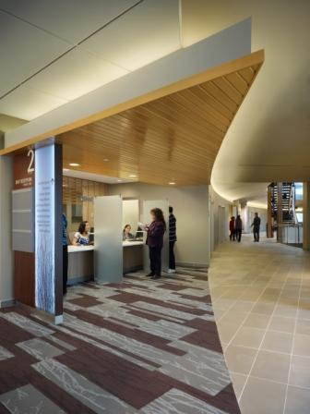

“It costs us $125,000 to recruit, orient and train a new PCP, so keeping them here and keeping them happy is essential” says Steve Tierney, Medical Director of Quality Improvement at South Central Foundation (SCF), a 115 physician clinic serving a mostly native population in Anchorage, Alaska. SCF has transformed into a patient-centered, team-based model of care over the past 8 years.

Employment at SCF is now highly sought. Physician retention is above the national average and unlike many institutions that can’t find enough nurses to hire there is a waiting list of nurses who want to work at SCF. What is their model and how did they do it?

What has Tierney learned about why primary care physicians are often unhappy? “When you give people who are control-oriented an impossible task to solve they get angry.”

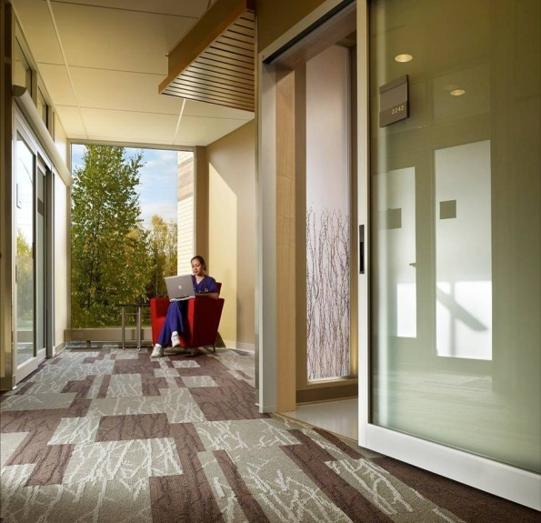

Care Model

Integrated Care Teams
“Integrated Care Teams” (ICT) comprised of a physician (or NP/PA), medical assistant, nurse case manager and clerk, co-located in the same workspace and stable over time, are the building blocks of the SCF care model. Each ICT provides care for a risk-adjusted panel of approximately 1300 patients. A pod of 5 ICTs is supported by a behavioralist, a part time medical director and a pod manager. These twenty or so people share a common work area, designed to facilitate communication among individual teams and across roles.

Co-location
SCF relies less on detailed care management protocols, but rather more on creating the interprofessional relationship that allow for intensive but customized management of their patients. Co-location fosters trust and reliance. The team learns how each other works. There is also efficiency, as the staff can just turn their head for fluid back and forth communication, rather than getting mired in the tangle of email and electronic messaging that we have observed in some practices.

On Time and at Goal: Collective Responsibility
Each ICT is collectively responsible for the quality outcomes of its population. The objective is to have patients receive their care elements “on time and at goal”. Nurse care managers armed with registries are the means of achieving these goals.

Nurse Care Manager and Virtual visits
SCF has de-coupled chronic illness care and prevention from office visits. The nurse care manager orders immunizations, mammograms and chronic illness labs as triggered by review of the panel’s registry, rather than as triggered by an office visit. She may do medication adjustment over the phone before or after a brief huddle with the provider. “None of our docs directly manage diabetes because it is on protocol. After a team has matured the nurse may make the med change herself later telling the physician ‘Mr. J’s A1c was 9.0 so I increased his glyburide from 5.0 mg/d to 5 mg BID is that ok?’
Nurses feel like peers with the providers on the team.“

At SCF the goal is to bring a patient in for an office visit only if that is the only way to meet their need. Whenever possible an office visit is replaced by a virtual visit, typically a phone visit with the nurse care manager.

Clerks
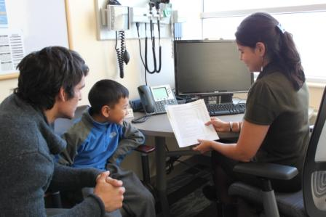
SCF found it was burning out case managers with all of the new responsibilities, so they added a clerical support person who sits physically next to the nurse to help her with paperwork and scheduling. Because of stability of the relationships the scheduler knows how this care team likes to schedule patients and do their work, allowing “customization at the team level.”

Medical Assistant and Office Visits
A patient with chronic illness can expect to make one prevention/chronic illness visit per year plus additional visits as needed for acute symptoms. For example, a patient with controlled diabetes may come in once a year, but have interval labs managed by the nurse.

For same day needs the goal is to “meet today’s need with a response today.”

The MA begins an office visit with a patient by performing standard screens for depression, substance abuse and smoking. He will also order pre-visit labs, queue up orders to be signed for labs, medication refills, medication changes and future order entry.
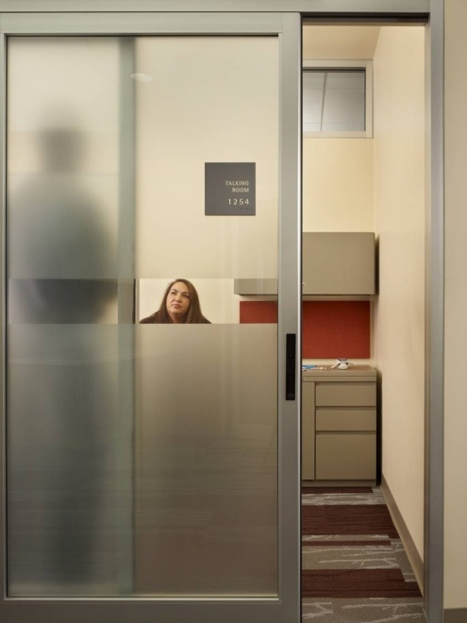

Behavioralists: On Demand Availability
About half of all visits at SCF are influenced by mental health issues. SCF has therefore hired a behaviorialist for each pod (5 providers) who is available on demand. The physician may review the depression screen performed by the MA and advise the patient “I see your depression screen is positive, (and ordinarily I’d be terrified to ask you about this), but now I have a counselor who will come in in 5 minutes and help us make a plan for you.”

Improvement Culture

Data
“Before we start something new, we set up our data infrastructure” Tierney explains. For providers who may be weary of a proposed change Tierney replies” Would you be open to a trial? I promise you that if we start having a negative change in our data we will go back. Would you be willing to give it a try under these circumstances?”

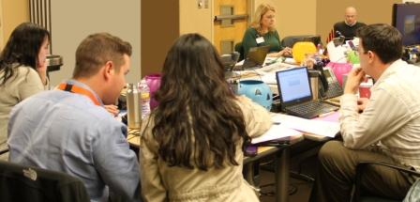
SCF’s Data Services department of 5 nurse epidemiologists actively monitors 370 clinical, operational and financial metrics and provide feedback so leaders and workers know if what they are doing is working. Performance scorecards highlight areas in need of further improvement. This team is responsible for presenting a robust data platform to inform change processes.

Change specialists
Tierney heads a staff of 26 improvement specialists charged with quality improvement and quality management. Most of these change specialists are hand-picked from within the organization and trained in-house. When a pod or a team wants to make a change they are assigned an improvement specialist, who assists with the change process. The improvement specialist will assemble data relevant to the proposed change, help map out an improvement plan, and then assist in assessing the success of the change. Physicians who are weary of the proposed change are assured “if this doesn’t work, if the data show this doesn’t work we will step back.’

Payment Model
Revenue streams for SCF include 60% fee-for-service (40% Medicare and Medicaid, 20% commercial) and 40% capitated through the Indian Health Service. The global payment perspective, however drives the culture. Tierney explains “Cost avoidance is more important to us then visit generation.”

Successes and Stumbles

Co-location
Tierney reports that it wasn’t until they remodeled the workspace for co-location of the teams that the additional nurse care manager and clerk added value to the model and individuals started functioning as a team. “Before this nothing changed. Role types didn’t mix.” Once team members rubbed shoulders throughout better working relationships developed.

“Early on in the transition of the system, we found trust was low between disciplines. We recovered this by sitting them together, and creating an environment where they talk frequently. Providers were uncomfortable ceding management of chronic conditions, but over time with multiple conversations about the same issues with the same people, trust grew and now most experienced teams can anticipate each other to the point where it almost appears they work independently. We started first with inter team relationship and then much later built content around standardizing approaches (scripting).”

Nurse case managers
Tierney acknowledges “We ended up losing some nurses who couldn’t go this direction, those who didn’t want to give work over to the MAs that had traditionally been performed by nurses including phlebotomy, vitals, and immunization administration.” Furthermore, early on in the transformation nurse case managers were burning out from their new responsibilities. It wasn’t until a nurse manager support person (the co-located clerk) was added that the job was doable.

Next steps, Future Vision
Tierney would like to develop additional integration of professional staff, brining a pharmacist into each pod to help manage a rolled up scored card and registry, and to interact fluidly with the teams.

He also has plans for a robust personal health record, using it to push web content to patients, for example, if a patient screens positive for depression, a pod cast on depression would be sent to the patient and the clinic would receive an alert to contact the patient for an appointment. He would also like to see the PHR and smart phone apps used for on-line health coaching and lifestyle motivation.

How Did They Do That: Many Steps along the Journey

Top Down
SCF began with a focus on visit through-put: improving the MAs role and visit efficiency. It was a top down strategy, and resulted in modest improvements, but was not transformative.

Discover and Spread
The real change came when the leadership vision shifted from “design and deploy” to “discover and spread.” As Tierney describes, “Instead of telling people what to do we discover what works by observing excellence.” SCF observes high performers and asks what about the people and the process was contributing to the better outcomes..

Improvement is a Line of Business
“We recognized that improvement was a line of business” Tierney explains. In response SCF created an Organizational Development Department and a change management infrastructure. Now all change is preceded by analysis with measurement infrastructure, set up before change occurs, is facilitated by improvement specialists, and is constantly monitored and refined. For those who might be reluctant they are offered brief “let’s try it” initiatives.

“We also established an internal “SCF University” where our high performers could teach others to work as they do. “

In addition, all staff are trained in skills around relationship and how that could influence/impact the outcome of any interaction (both with customers and staff”.

SCF has begun to explore the dimension of provider and staff work styles and personality, using personality profiles to inform their approach to supporting staff through change. Each employee, including physicians, undergoes personality testing. Tierney explains “Some providers with high scores in safety, security, and moral platform would tend to struggle with change, and over-intervene with patients. They worked harder, longer, were more frustrated and had more perceived powerlessness… In contrast, providers with low safety and security, high sociability, low moral platform, and high rule break were very likely to experiment and creatively discover new and innovative ways to problem solve. …This does not mean we dismiss those who need a high degree of safety and security. We just support them differently. We use the risk taking rule breakers to investigate/explore and the reticent organized types to execute/maintain. Both now feel they can make a valuable contribution to the company; and we can just recognize the difference in their specific type of contribution.”

Tierney concludes: “My job is not to tell others what to do, it’s to ask them what they need. They already know what to do, how it’s doing and where it’s expected to be. They fix that, I support them.”

Baldrige Award

In 2011 SCF was one of four organizations to receive the prestigious Baldrige National Quality Award, the highest level of national recognition for performance excellence a US organization can receive.

Addendum: Note from Don Berwick’s IHI Plenary lecture “The Moral Test” Dec. 2011

If you doubt it, visit the brilliant Nuka care system at Southcentral Foundation in Anchorage, which just won the Baldrige Award. I visited in October. Thoroughly integrated teams of caregivers –physicians, advanced practice nurses, behavioral health specialists, nutritionists, and more – occupying open physical pods in line-of-sight contact with each other all day long, weaving a net of help and partnership with Alaska Native patients and families. The results: 60% fewer Emergency and Urgent Care
Visits, 50% fewer hospitalizations, and 40% less use of specialists, along with staff turnover 1/5th as frequent as before the new care.

